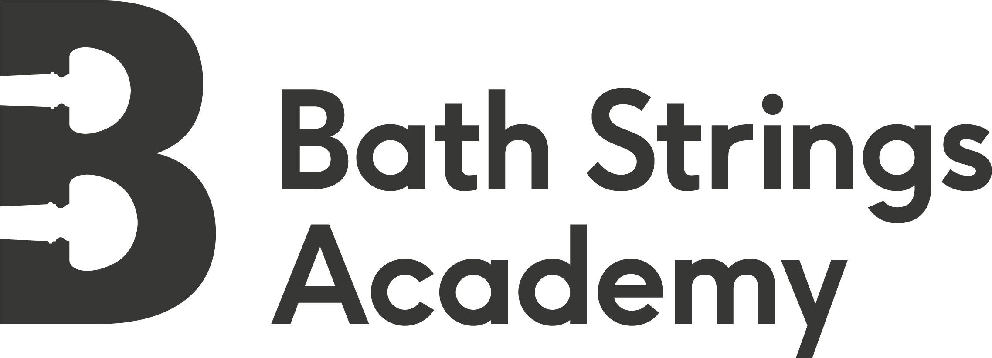

Summer Academy Report

August 2018

Bath Strings Academy was delighted to have the support of ESTA through the Joan Dickenson Chamber Music Fund for our Summer Academy which took place between 29 – 31 August this year.

Our Academy has been running for just two years, and it has always been part of our vision to include a chamber music strand in our summer course. With ambitious plans to expand our musical offering we realised the need to raise funds, so thanks to the warm generosity of friends, students’ families, colleagues and local benefactors we managed to raise £6000 in support our work, through our Crowdfunder campaign. This enabled us to give four bursaries to students who would not otherwise have been able to attend, along with two chamber music scholarships and the funds to engage excellent teaching staff. We were delighted to be able to invite James Dickenson and Nick Stringfellow of the Villiers Quartet to coach our musicians and it was a real treat for our local players to have the benefit of such high-calibre expertise. We were also joined by cellist Rachel Watson of Scordatura Womens Music Collective, Seona Pritchard, Klezmer and folk specialist, and Charlotte Sloane-Hill, Dalcroze tutor.

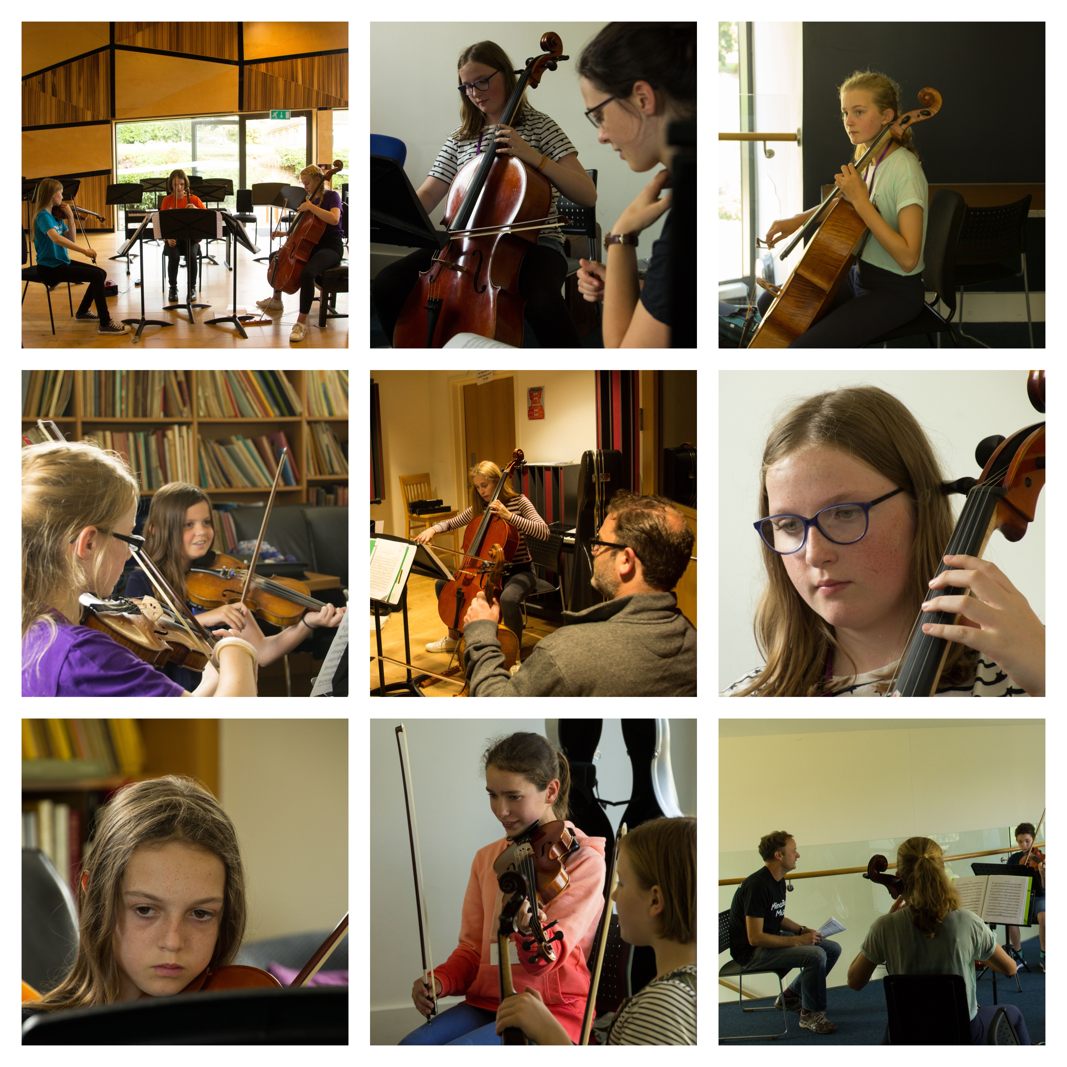

Of the thirty-seven students who joined us this summer, eleven string players took part in the chamber strand of the course, many of them experiencing their first taste of playing chamber music. They studied a Schubert trio, plus early Mozart and Beethoven string quartets, and took to the challenge like proverbial ducks to water.

“I enjoyed working in smaller groups; it was hard but in a good way! I learned how to balance everyone’s parts”. (Amelia, violinist, 15 years old)

Bath Strings Academy courses are designed to embrace music-making in a holistic way, hence our motto “mind, body, music”. We aim to develop the whole musician so that our students listen and play music together with optimal focus. Our players took part in daily warm-up sessions that develop healthy physical habits, alongside performance practice sessions. These skills are crucial to the developing chamber musician. What a joy it is to behold chamber groups who have honed these skills so successfully that they play as if they were one living being! The Dalcroze Eurythmics session our chamber players took part in was designed to build these skills so that players became more aware of each other, synchronising breathing, moving and feeling the pulse together.

“It was interesting to learn how your body can help you make music as well as your playing”
(Alice, violinist, 11 years old)

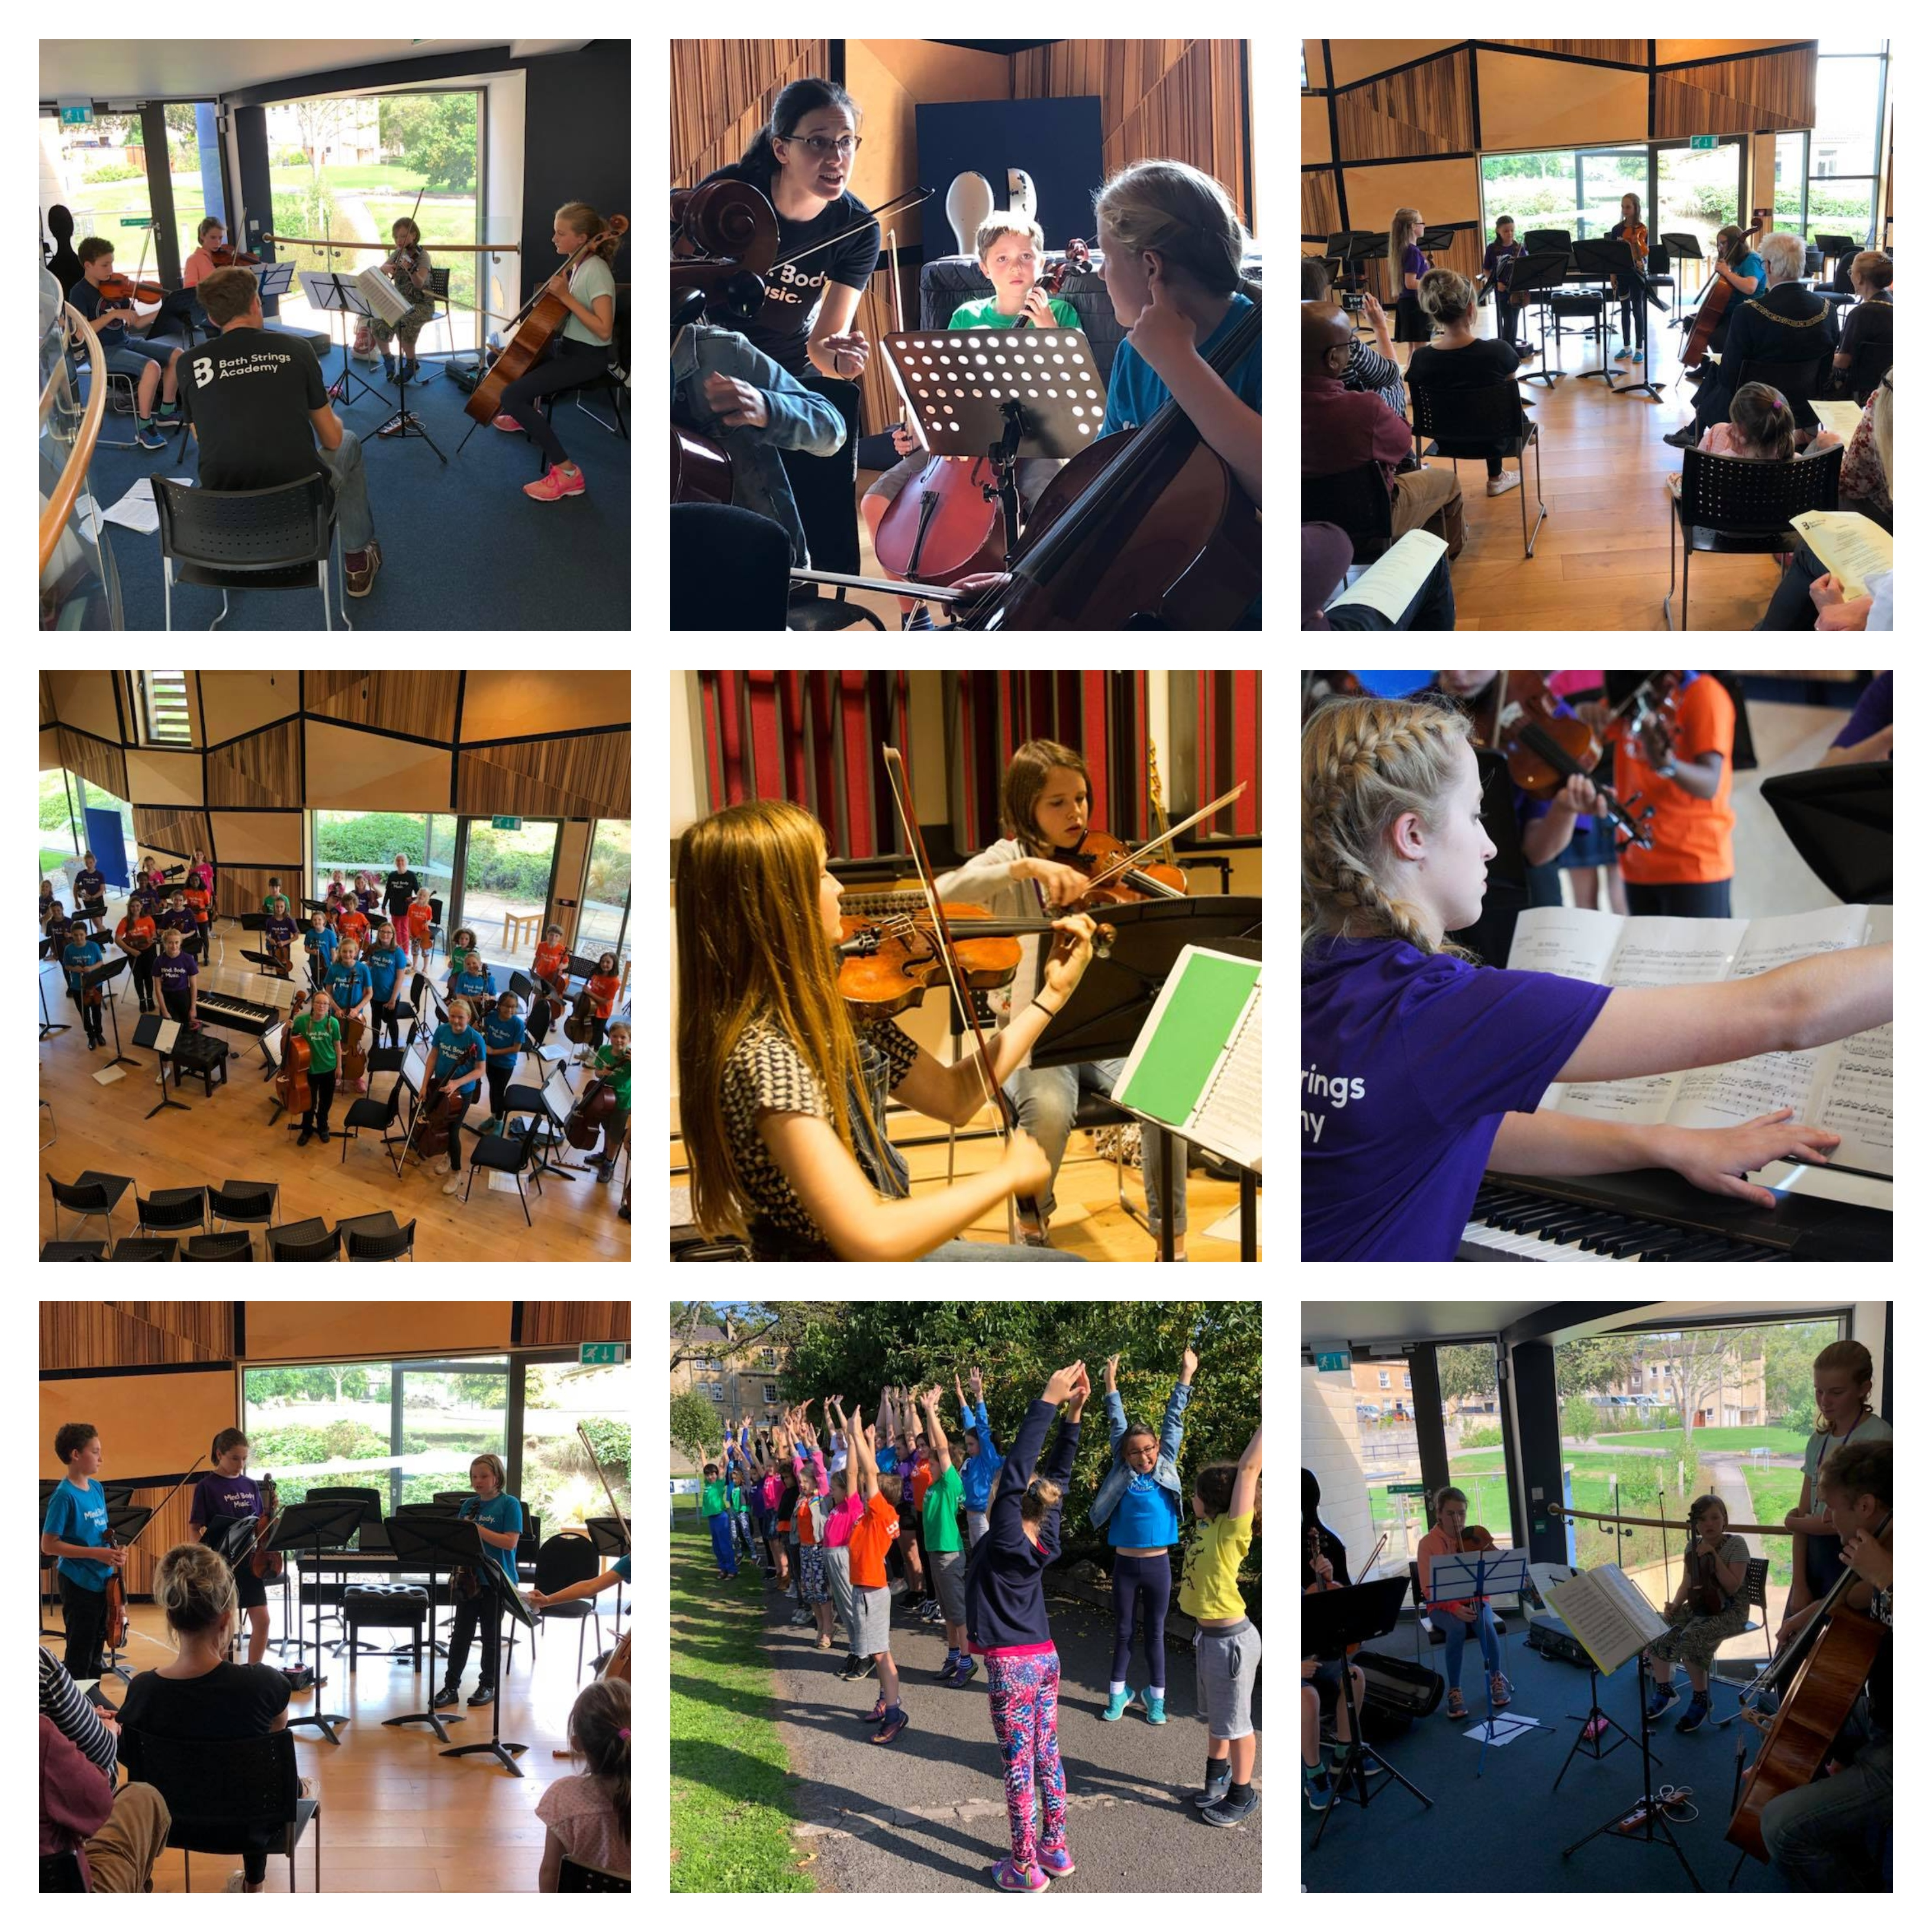

On Day 2 of the course, our participants were treated to a staff performance of Schubert’s most glorious work, the String Quintet in C. It is so important for students to see their teachers performing; not only should this inspire them, but and also expose them to the repertoire which they might not otherwise have the opportunity to hear. Whilst students and their families took on the role of attentive audience, our staff modelled the performance practice techniques which we aim to instil in our pupils.

“I really enjoyed the Schubert Quintet in the staff concert! I am playing it this term and it was really useful to hear it played live.” (Flora, violinist, 13 years old)

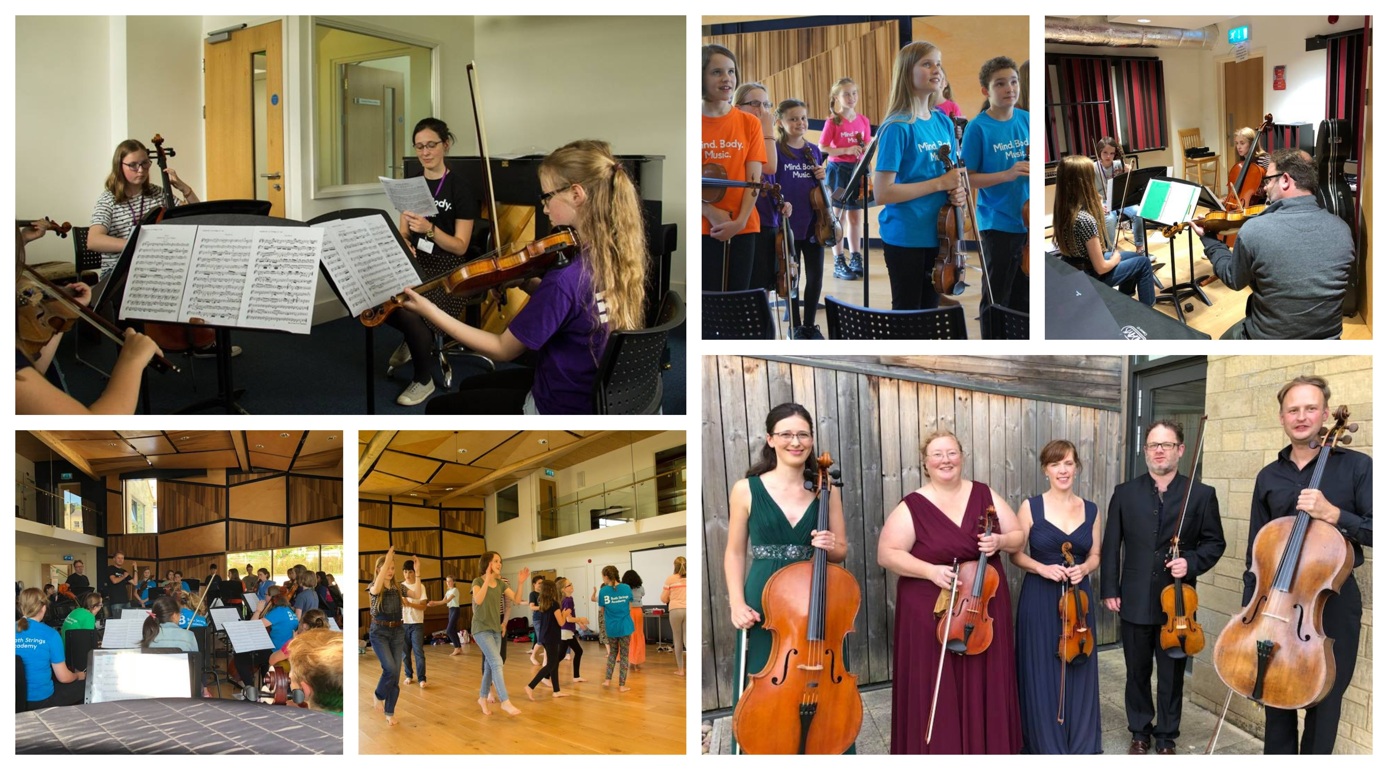
The culmination of our students’ efforts on Day 3 was a joy to behold, with our chamber players producing some very moving performances of their studied works. The progress made by all in just three days was amazing!

The Finale Concert included an amalgamated performance of Corelli’s ‘La Folia’ with our main course participants providing the Ripieno to our chamber participants, who took it in turns to play the solo variations in their Concertino group. The performance was given without a conductor and the Academy orchestra was led with stylistic aplomb by one of our scholarship students, Flora Clapham.

To see children aged from 7 to 15 years old ranging from beginner to Diploma standard, playing side-by-side was a real inspiration for all involved. The Mayor of Bath, Councillor Patrick Anketell-Jones remarked:

“The concert was truly marvellous! I loved the diversity of music from classical to folk, chamber to orchestra and the fact that you have everyone involved from the little ones right through to a very high standard. Wonderful!”

And our youngest chamber participant, violinist Hester, aged 10, summed it up by saying:

“I enjoyed the chamber music the most and I learnt to play with confidence. Everything is so nice here and everything is so fun! In the concert everything is relaxed and it made me feel relaxed.”

Luckily Hester, that is absolutely what we were aiming for!

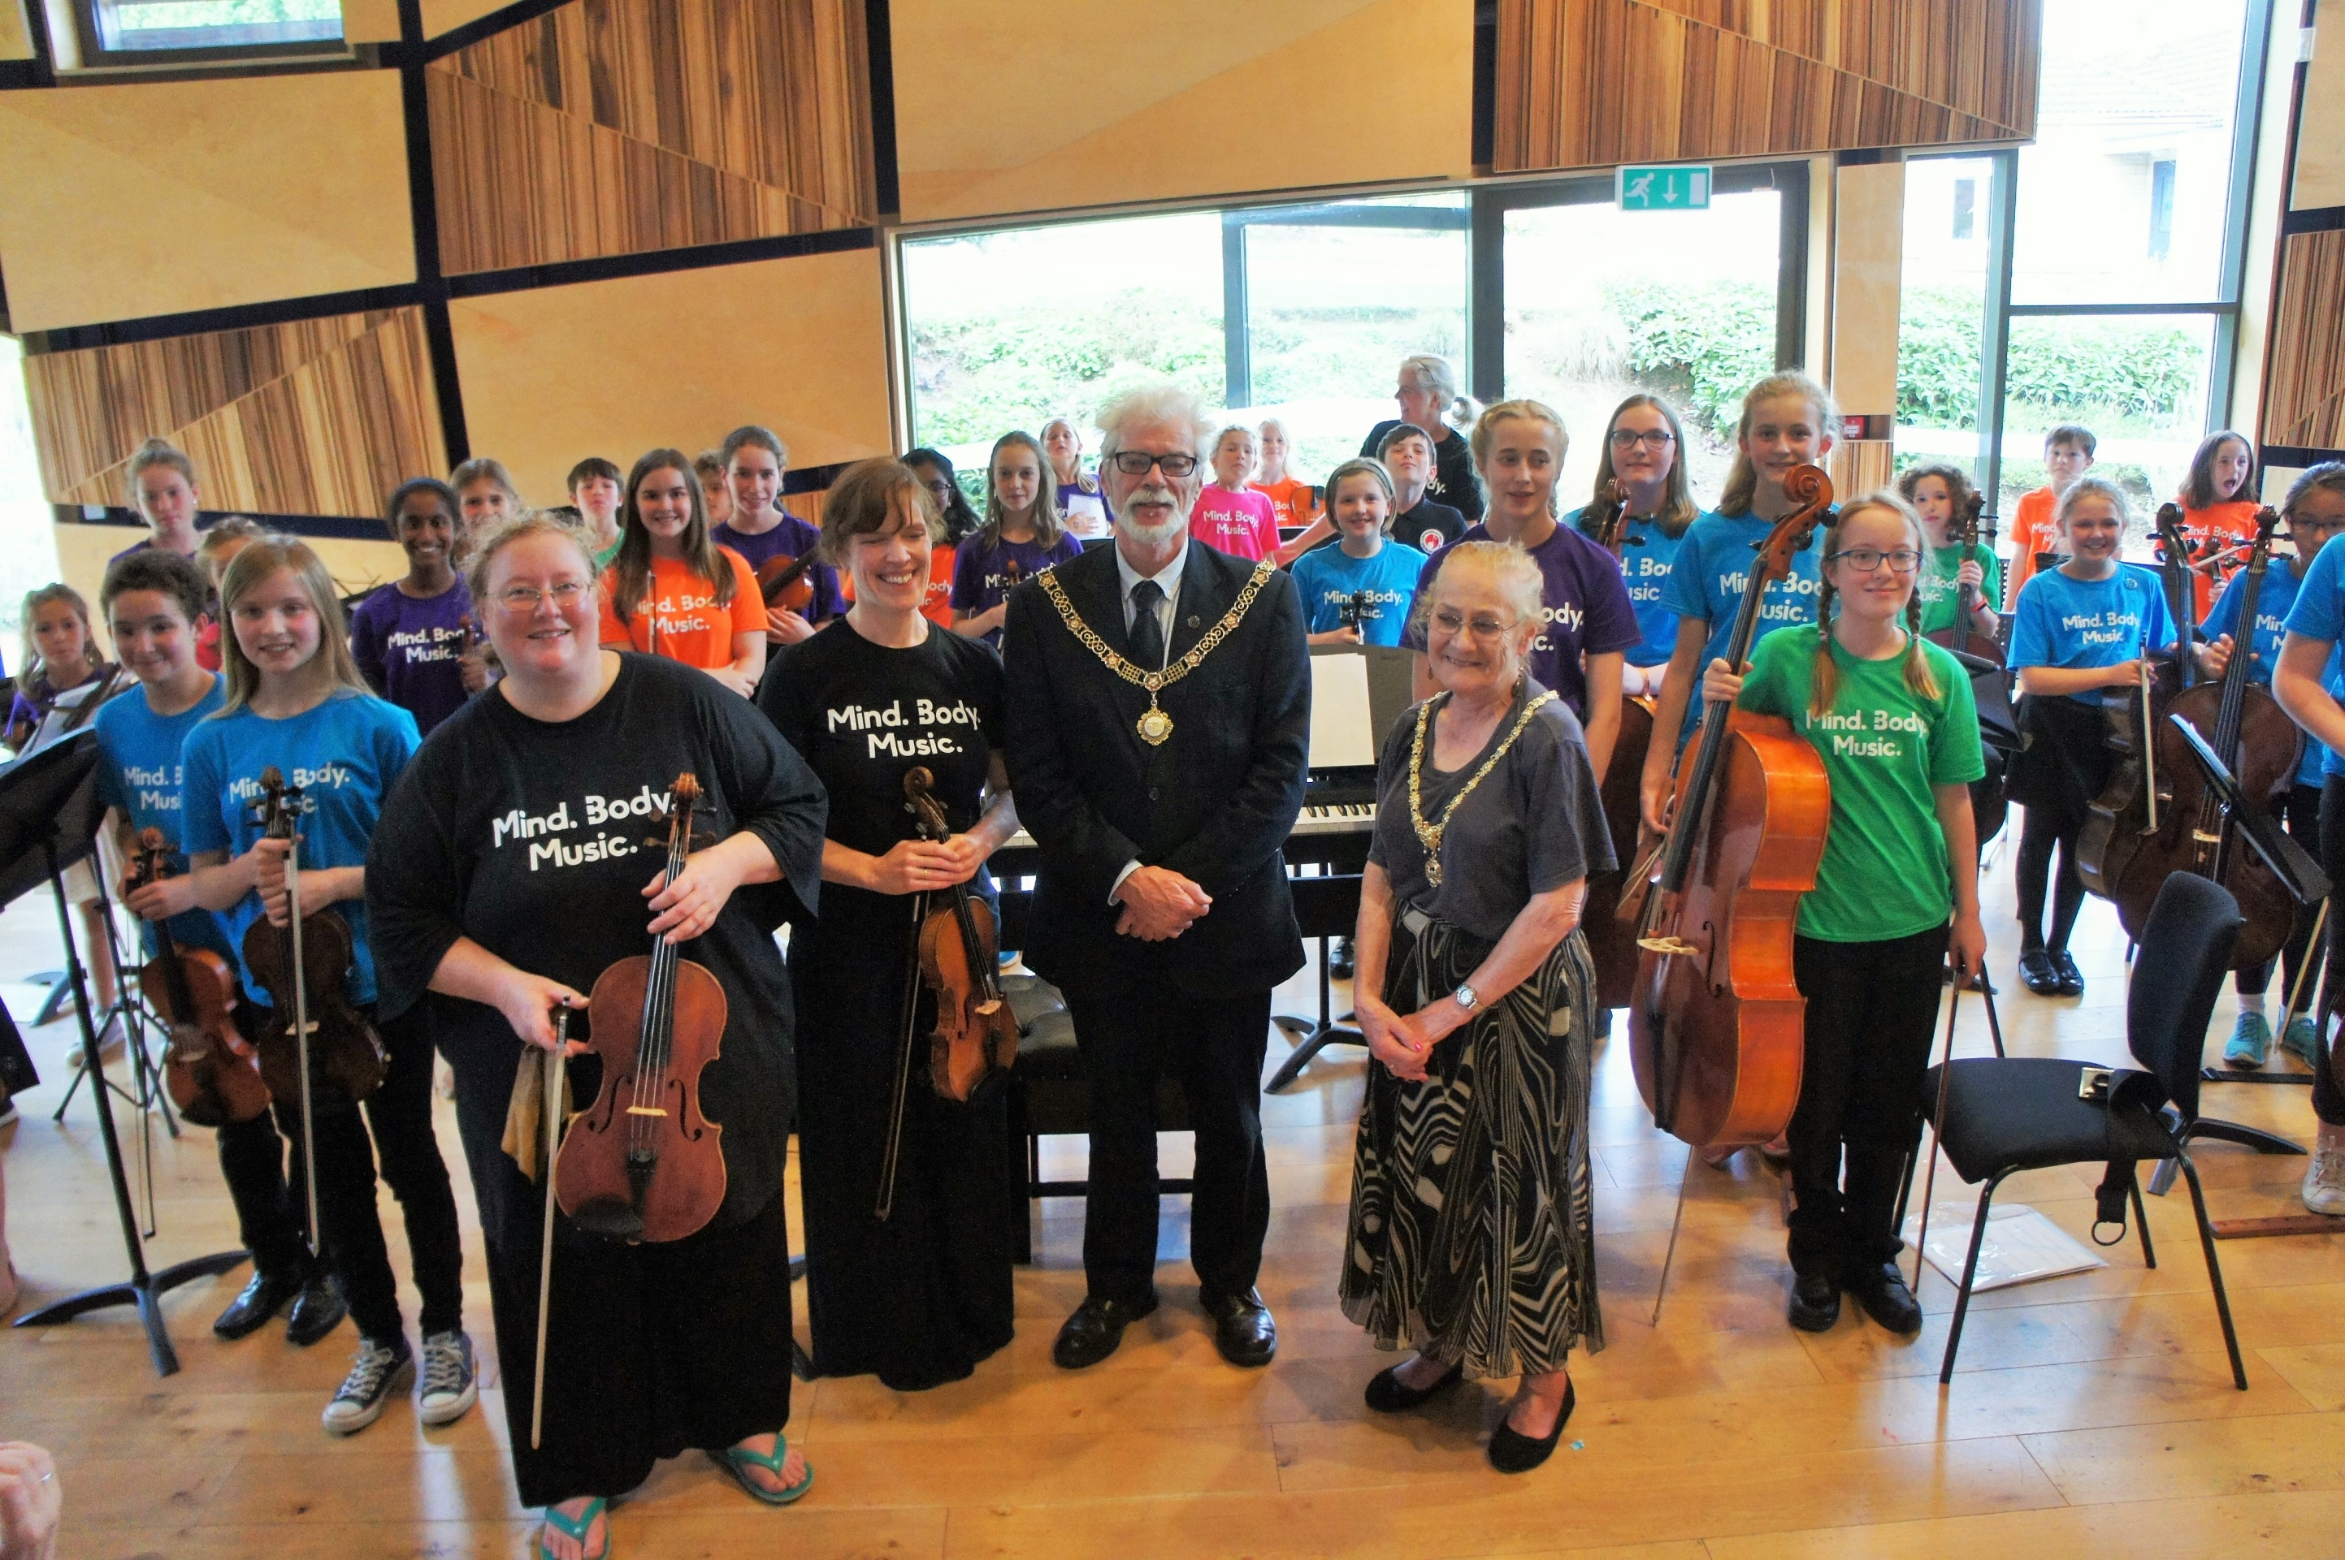

Summer Academy 2018 – with the Rightworshipful Mayor of Bath, Councillor Patrick Anketell-Jones

By Michelle Falcon & Ruth O’Shea
Co-Directors Bath Strings Academy CIC

