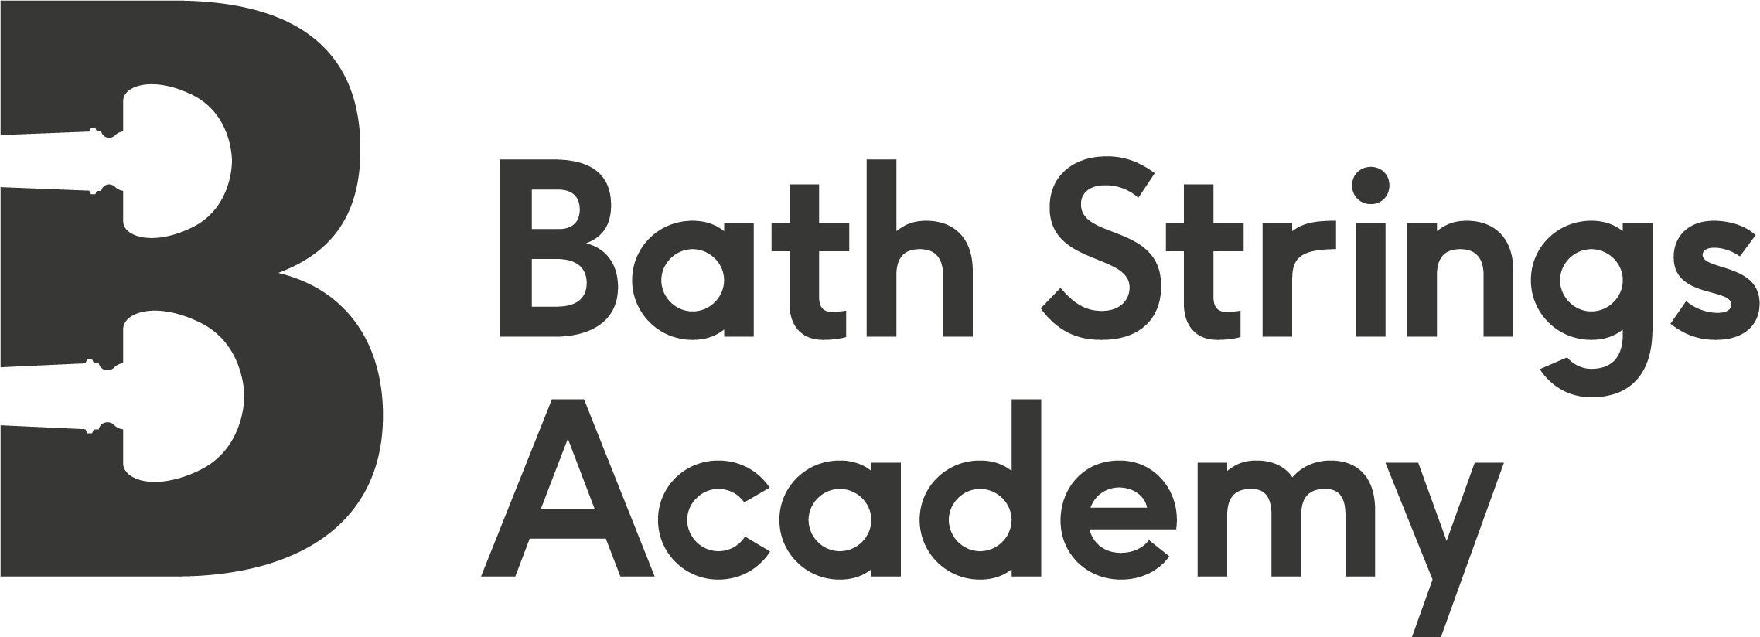
Bath Strings Academy Extended Hours Booking Form

If you would like to make use of the extended hours for childcare, please complete the table below.
- Extended hours are charged at £6 per hour or pro rata in 15 minute increments (i.e. £1.50 per 15 mins)
- Children will be supervised during this time, but will need to bring their own (non screen-based) entertainment. Drawing equipment, card games and lego will be provided.
- Please ensure you collect your child by your stated booking time.
- If you are going to be late please phone us on 07962 864823.

Child's Name: _______________________________________ Mobile Contact No: _________________________________

Tick the boxes below for the hours that you wish to book and calculate the additional fee, which will need to be paid at the time of booking to Bath Strings Academy CIC account number: 26436733; sort code: 09-01-29
.
 | DAY 1:  28/08/19 | DAY 2:  29/08/19 | DAY 3:  30/08/19 | Charge per day | Total Additional Fees
AM - DROP OFF TIME | Tick drop-off time as appropriate | Tick drop-off time as appropriate | Tick drop-off time as appropriate
8.30am |  |  |  | £7.50
8.45am |  |  |  | £6.00
9.00am |  |  |  | £4.50
9.15am |  |  |  | £3.00
9.30am |  |  |  | £1.50
9.45am | No charge | No charge | No charge | No charge
PM - PICK UP TIME | Tick pick-up time as appropriate | Tick pick-up time as appropriate | Tick pick-up time as appropriate
4.15pm |  |  |  | £1.50
4.30pm |  |  |  | £3.00
4.45pm |  |  |  | £4.50
5.00pm |  |  |  | £6.00
5.15pm |  |  |  | £7.50
5.30pm |  |  |  | £9.00
6.00pm |  |  |  | £10.50
 |  |  |  | TOTAL | £

