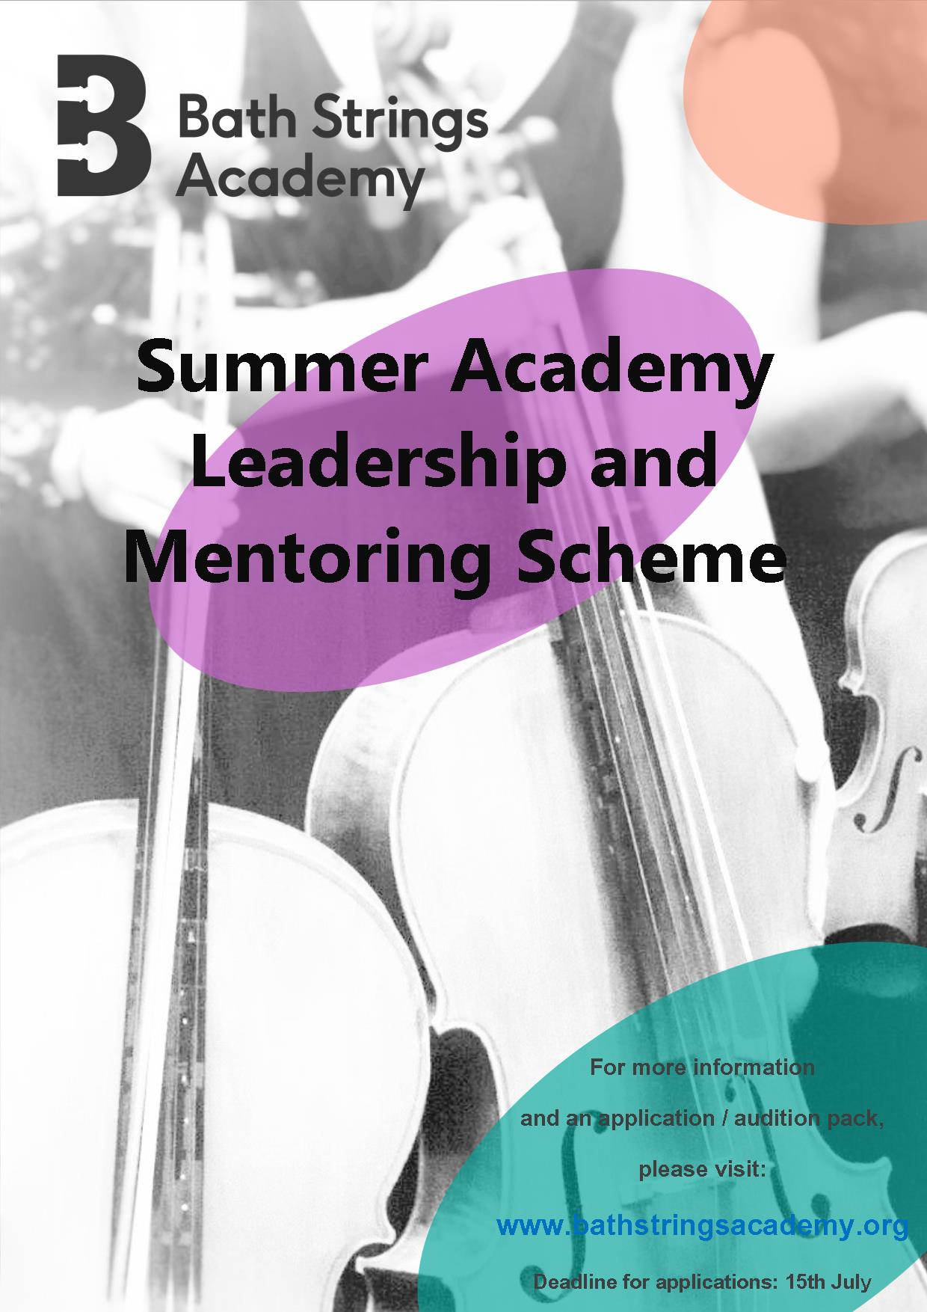

Hands-on teacher training
and chamber music coaching
for exceptional string players
with an interest in teaching

Advanced Leadership
and Mentoring Scheme

Applications for our Advanced Leadership and Mentoring Scheme are invited from string players of the violin, viola, and cello who are enrolled on an undergraduate or postgraduate Music Degree course at a University or Music College.

Summer Academy Advanced Leadership and Mentoring Scheme

Candidates for these places need to be highly competent musicians with a positive attitude and an interest in teaching. Places are awarded on the basis of a written application and endorsement from your educational institution.

Four places are available at a subsidised cost of £220 for four days:
- 2 violins
- 1 viola
- 1 cello

The Scheme consists of:
- Subsidised attendance at our Summer Academy as an Advanced Specialist Mentor, involving teaching and leading selected activities.
- An additional training day one day before the course begins, during which Mentors will receive training on our philosophy and will be fully briefed on the key areas of course content. This will be a practical and interactive session.
- The opportunity to rehearse as a string quartet, preparing repertoire and receive coaching from the chamber course tutors from the UK’s leading chamber ensembles. We believe in a holistic approach, so your tuition will include performance and stagecraft aspects such as mental preparation, physical stage presence and how to effectively communicate with your audience. You will have the opportunity to perform as a quartet and as part of the Bath Strings Academy ensemble.

Application Process:

A written application using the attached form, accompanied by a reference from the candidate’s educational institution should be submitted by email to bathstringsacademy@gmail.com .

Applications will be assessed by a panel including an independent adjudicator. Shortly after the application deadline, candidates will be sent a selection of excerpts to prepare from the chamber music repertoire. Following assessment of the submissions, a shortlist of candidates will be invited to take part in a short interview, either in person or via video link (Skype or similar) to perform the excerpts and discuss the candidate’s interests and ambitions.

Successful candidates will be informed of their selection by the end of July. Full payment of the course place of £220 will be payable on acceptance.
Advanced Leadership
and Mentoring Scheme

Thank you for applying for the Advanced Leadership and Mentoring Scheme. Please note that in order to complete the application process, you must submit the following:

- Completed application form.
- A musical reference from your educational institution.

Please send your application by email to bathstringsacademy@gmail.com

The deadline for applications is 15th July.

Please note: all questions marked with an asterisk * are required answers.

Applicant Details

First Name* Surname*

Preferred Name (if applicable) Gender
Male
Female
Prefer not to say

Date of Birth (dd/mm/yyyy)* Age at August 2019*

Academic Year Group from September 2018

Address (including county and postcode)*

Section 2 – Educational Institution Details

PART A

Institution attended by applicant

Type of Institution:
University Music College

Institution address (including county and postcode)

Name of Instrumental Tutor Name of Head of Music Department

Course Details

Please give the full name of your course, and a summary of elements completed to date. Please include marks obtained in summative assessments, including performance.

Section 3 – Instrument Details

Please indicate your primary study instrument and any other instruments studied. Give details of any qualifications already obtained, including dates and marks, or an indication of playing standard.

Primary instrument * Approximate standard *

Second instrument * Approximate standard *

Third instrument * Approximate standard *

Fourth instrument * Approximate standard *

Section 4 – Musical and Teaching Experience

Please give a brief overview of your musical experience to date. Please give details of any ensembles or groups in which you play regularly, any performances you have been a part of, masterclasses you have attended, concerts you have been to including any experiences you consider highlights. Please continue on an additional sheet if required.

Please give us some examples of your teaching experience, including any placements undertaken* Please give details of particular tasks undertaken, along with any specific teaching skills and techniques acquired. Please continue on an additional sheet if required.

Section 5 – Supporting Evidence

Musical Reference
In order to complete the application process we also require a musical reference from your educational institution. This can be from anyone who knows you musically and who can vouch for your musical talent, commitment and enthusiasm.

Please send the guidance notes at the end of this document to your referee, and send their reference as an attachment to your application email when you are ready to submit your application. If your referee prefers to keep their reference confidential, please forward them your completed application form and ask them to email it to us with their reference attached.

SEE ANNEX 1 FOR GUIDANCE NOTES.

Section 8 – Confirmation

How did you hear about Bath Strings Academy? *

BEFORE YOU SUBMIT YOUR APPLICATION, PLEASE READ THE FOLLOWING CAREFULLY:

In order for your application to be valid, you must return a completed application form and a musical reference. Failure to submit all of the above may result in your application being invalid.

Please tick the boxes below: *

I have read and understood the above statement and I can confirm that I will be submitting the following:

A completed application form
A musical reference attached as a Word document / PDF to my application email

Please enter the full name of the applicant as confirmation that you have answered all of the questions correctly and read and understood the application requirements *

Name*

Date *

Data protection statements Bath Strings Academy will use the information you have provided here for the purposes of administration and marketing. If you would prefer not to be included on the newsletter mail-outs, please tick this box

Bath Strings Academy may use details provided here for statistical and reporting needs to funders (not including contact details).
Please tick this box if you would prefer for your data not to be used

PLEASE NOW ENSURE THAT YOU HAVE SAVED YOUR FINAL VERSION OF THIS FORM, ADDING THE APPLICANT’S NAME TO THE FILE NAME SO IT READS: “YourNameBSA2018”
THEN PLEASE RETURN IT TO: bathstringsacademy@gmail.com

The deadline for applications is 15nd July

ANNEX 1

Bath Strings Academy Advanced Leadership and Mentoring Scheme

GUIDANCE NOTES FOR REFEREES

Candidates for these places need to be highly competent musicians with a positive attitude and an interest in teaching. Places are awarded on the basis of a written application and endorsement from the applicant’s educational institution.

Referees should be a member of teaching staff from the candidate’s educational institution who knows them well and can vouch for their inter-personal skills as well as their musical ability.

Referees should provide:

- Their Name.
- A contact email address and/or phone number.
- Details of how long they have known the applicant, and in what capacity.
- Their knowledge and opinion of the applicant’s instrumental skills and overall musical ability, with particular reference to any chamber music experience.
- Their opinion of the applicant’s suitability to perform the role of Advanced Leader/Mentor, working with children of all ages and levels of experience, including information about the applicant’s teaching experience, if any.
- Their views and experience of the applicant’s general attitude, reliability and approach to working with others.
- Details of any financial support that may be available from the applicant’s educational institution to facilitate their participation.

